ÇARPMA İŞLEMİ
* Aşağıdaki çiçeklerin yapraklarını toplama ve çarpma işlemi olarak yazın.
4+4+4=12 | 3 tane 4, 12 eder.
3x4=12 | 3 kere 4, 12 eder.
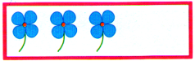

..................................... | ..................................
..................................... | ..................................
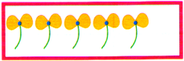

..................................... | ..................................
..................................... | ..................................
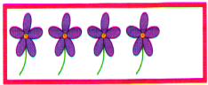

..................................... | ..................................
..................................... | ..................................
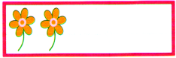

..................................... | ..................................
..................................... | ..................................
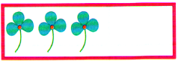

..................................... | ..................................
..................................... | ..................................
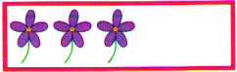

..................................... | ..................................
..................................... | ..................................
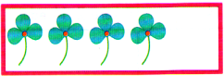

..................................... | ..................................
..................................... | ..................................
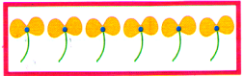

..................................... | ..................................
..................................... | ..................................
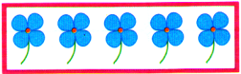

*Aşağıdaki uğur böceklerinin üstündeki benekleri toplama ve çarpma işlemi olarak yapın.
..................................... | ..................................
..................................... | ..................................


  
  
